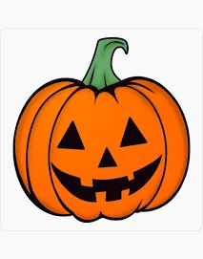Should Christians celebrate

**Halloween**?

**Abstain from all appearance of evil**

**1 Thessalonians 5.22**

**Whether therefore ye eat,**

**or drink,**

**or whatsoever ye do,**

**do all to the glory of God.**

**1 Corinthians 10.31**

**Whatsoever things are true, whatsoever things are honest, whatsoever things are just, whatsoever things are pure, whatsoever things are lovely, whatsoever things are of good report;**

**if there be any virtue, and if there be any praise,**

**think on these things.**

**Philippians 4.8**

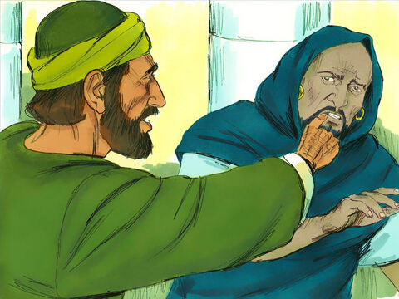

**Elymas / Bar-jesus**

O full of all subtilty and all mischief, thou child of the devil, thou enemy of all righteousness, wilt thou not cease to pervert the right ways of the Lord? **Acts 13.10**

**For we wrestle not against flesh and blood, but against principalities, against powers, against the rulers of the darkness of this world, against spiritual wickedness in high places. Ephesians 6.12**

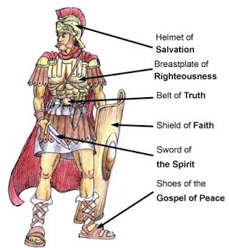

**Armour of God**

